|  |
| --- |
| Edinburgh napier university |
| **SET09107: Advanced Database Systems 2019/20 Coursework** |
|  |
|  |
| **Brogan Murphy** |
| **40340890** |

Contents

Task 1

Task 2 – Re-Design the database

Structured Types

Tables

Alternative Design

Task 3

Branch table test data

Account table test data

Employee table test data

Customer table test data

Task 4

Question A - Find employees whose first name includes the string “st” and live in Edinburgh, displaying their full names.

Question B - Find the number of saving accounts at each branch, displaying the number and branch’s address.

Question C - At each branch, find customers who have the highest balance in their savings account, displaying the branch ID, their names, and the balance.

Question D - Find employees who are supervised by a manager and have accounts in the bank, displaying the branch address that the employee works in and the branch address that the account is opened with.

Question E - At each branch, find customers who have the highest free overdraft limit in all current accounts that are joint accounts, displaying the branch’s ID, the customer’s full names, the free overdraft limit in his/her current account.

Question H – Employee Awards at the end of the year

Task 5

Critically discuss the advantages and disadvantages of the object-relational model against the relational model, based on the designs and implementations for the proposed bank database. (8 marks)

# Task 1

**Draw an ER diagram corresponding to the relational database schema and the scenario. (5 marks)**

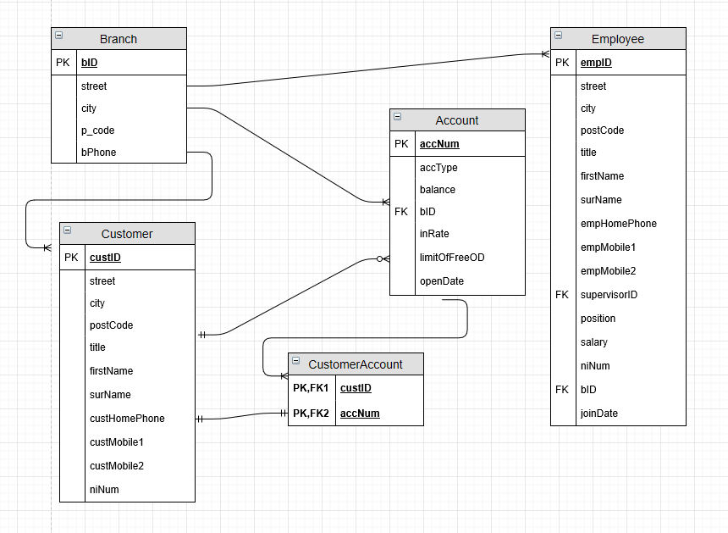

# Task 2 – Re-Design the database

I re-designed the database using a object-relational fashion. This consists of features found in a relational database but with object-oriented features such as inheritance and the use of objects (structured types). The new design consists of 6 types, 3 subtypes and 5 tables.

## 

## Structured Types

A structured type is a user-defined type which a user can define attributes, create member functions and create tables based on the type, for instance, a user may create a customer type, add a member function which prints the customers name and creates a customer table of the customer type. Types can be used as composite attributes, for instance, a name type consisting of a title, first name and surname can be used in other types as composite attributes and its components can be accessed using dot notation, e.g. personname. FirstName.

A structured type for an address was created in order to store values for a street, city and postcode. It is the supertype for the branch type. It is also used as a composite attribute in various tables within the database. It includes a member function, a feature of PL/SQL which allows operations to be performed with the attributes used within the type, to display an address to display a real value

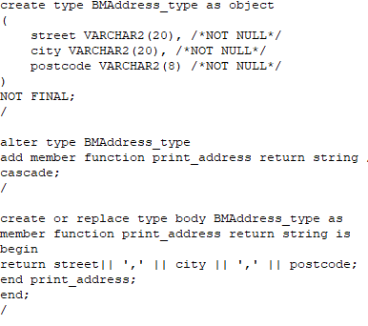

A structured type for a name was created so that a title, first name and surname could be stored. It is used as a composite attribute in various tables within the database.

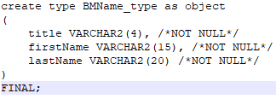

A structured type for Phones was created to store the phone type e.g. customer mobile and the phone number. This is used to create a nested table within various tables to store 1 or more phone type and number.

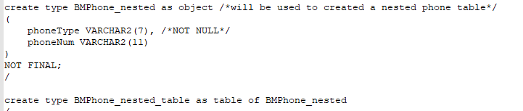

A structured type for a person is created, this includes base attributes address, personName, phoneNumber and NI Num. It is a supertype that the employee and customer type inherit from. It also includes a member function to display a real value for address.

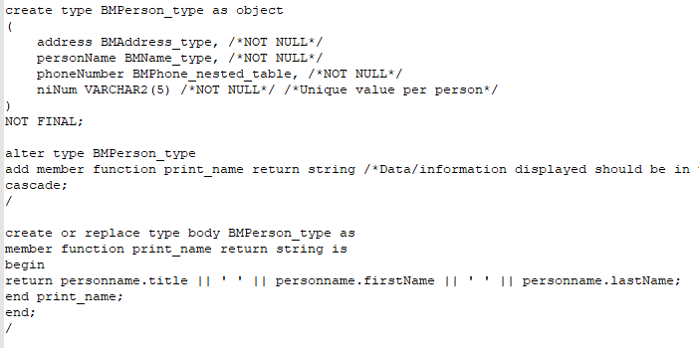

A structured type for a branch is created. This stores a branch ID and a phone number, it inherits the address of the branch from the branch type. It is used to create the branch table.

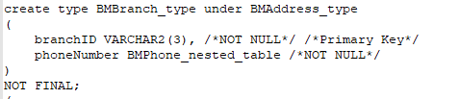

A structured type for an account is created. This contains attributes that the the account table will consist of. We can see that beside ‘branchID’ there is a reference declaration. This is a logical pointer to instance object, in other words, a row in a table that has been created from the ref type, e.g. as branchID references BMBranch_type and branch_table is created from BMBranch_type, the ref will point to the branchID in the branch table, meaning the values of that row can be accessed using dot notation, e.g. a.branchid.branchid.

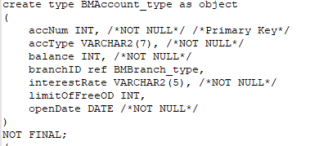

A structured type for employee was created. It is a subtype, inheriting its attributes from the supertype BMPerson_type and has a branchID ref pointer. It also has a supervisorID pointer which points to the employee type. This is used for assigning a supervisor to an employee, it points to another employeeID in the employee table and the values of that ID can be accessed using dot notation. An example is say employee ID E100 is a head, if they supervise a manager, their supervisorID will be E100, this can then be used to display the supervisor’s name, supervisorID etc through the use of dot notation.

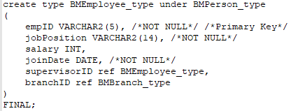

A structured type for customer was also created. It is a subtype, inheriting its attributes from the supertype BMPerson_type. It has an attribute for customerID.

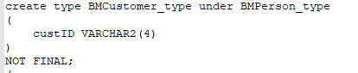

## Tables

Object relational databases allow tables to be created from user-defined types. I used my structured types to create 4 out of 5 of the tables. The other table was created using references.

A branch table was created to store the branch details. As I defined all the attributes in the branch type, all I had to do apply constraints. I used the PRIMARY KEY constraint for branchID. It is used to identify the primary key of a table and ensures the value must be unique for each row. I also used the CHECK constraint, which validates a row when it is being inserted to ensure it matches a specified criteria, the criteria being for each row apart from branchID that the value IS NOT NULL. NOT NULL is another constraint itself that a column in a table cannot contain a null value. I also created a storage table, branch_phone_nt, which stores the inserted values phoneType and phoneNum.

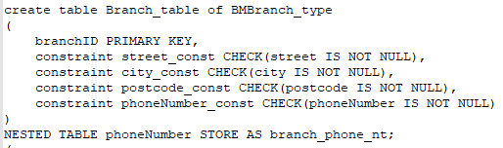

An account table was created to store each account in the bank. Yet again, only constraints and a storage nested table were needed as attributes were defined in the BMAccount_table. I used the PRIMARY KEY, CHECK and NOT NULL constraints again, but for the accType constraint, I ensured that only values ‘savings’ and ‘current’ could be entered at insert time, otherwise, an error would occur if anything else was entered.

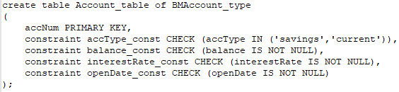

An employee table was created to store all the employee details of the bank. Us e of the constraints PRIMARY KEY, CHECK, NOT NULL were featured again, butn there was also use of the UNIQUE constraint, which validates an attribute to be unique for every row in the table. This was used for the NI number as it is unique for every person. We can also see CHECK being used to validate inputs to a match a specified criteria for jobPosition.

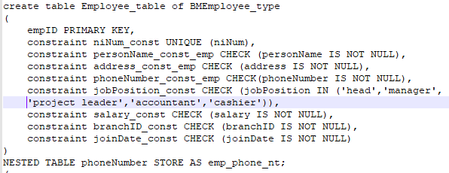

A Customer table was also created to store all the bank’s customer’s personal details. There is use of the PRIMARY KEY, UNIQUE for the Ni Number, CHECK and NOT NULL constraints and a storage table for any phone type(s) and number(s).

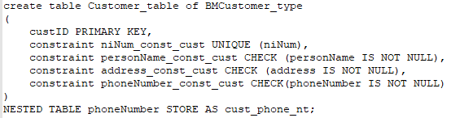

The last table, customer_account, is a table which is populated by the ref function. It is used to link the customer and account tables together. We can see that the primary key’s for both the customer and account tables, custID and accNum, are used to create this table. They enable the use of dot notation to access attributes in their tables, e.g. custID.custID or accNum.accType.

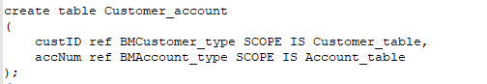

## Alternative Design

One alternative I considered was the use varrays. Varrays are ordered lists where their lengths are defined meaning they must be given a maximum amount in their declaration. Individual elements cannot be deleted from them making them dense, also , say a customer contacted the bank and asked for a phone number to be removed, all phone numbers that the bank have for that customer would be removed meaning time would be spent re-entering phone numbers. Nested tables were chose over varrays, as they are limitless, can store multiple data types and allow individual elements to be deleted from them.

I also decided against the use of a job table, which would store a jobID, a job position and a salary which could later be used in referencing to the employee table. This would enforce the use of the object relational concept, however I decided against it as it was not a feature of the old database design and creating the attributes in the employee type and entering the values of the employee type also worked fine.

# Task 3

## Branch table test data

|  |  |  |  |  |
| --- | --- | --- | --- | --- |
| **BranchID** | **Street** | **City** | **Postcode** | **Phone Number (nested table)** |
| S1 | 1 high st | Edinburgh | EH1 1TY | 'branch', '01312345678' |
| S2 | 34 queen street | Glasgow | WH10 7OY | 'branch', '01417854532' |
| S3 | 12 bruntsfield place | Edinburgh | EH11 4YD' | 'branch', '01317650912' |
| S4 | 49 tall crescent | Dundee | UI78 9VB | 'branch', '01512345678' |
| S5 | 20 barclay way | Edinburgh | EH13 7UF | 'branch', '01313762170' |
| S6 | 39 plover brae | Perth | UH4 0ER | 'branch', '01617650912' |
| S7 | 36 rose st | Aberdeen | PK13 6BV | 'branch', '01714324760' |
| S8 | 12 gent lane | Livingston | EH54 4ZX | 'branch', '01506423567' |
| E1 | 17 oxford st | London | OL13 5LP | 'branch', '07175654321' |
| E2 | 78 oak rd | Manchester | MA13 7LK | 'branch', '08147658900' |
| E3 | 45 ford st | Birmingham | BI71 2QW | 'branch', '09819265456' |
| E4 | 71 fleet st | London | OL17 4MN | 'branch', '07178790012' |
| E5 | 52 wallaby way | Cambridge | CA13 5LP | 'branch', '09543432129' |
| E6 | 89 top st | Liverpool | LI34 7MC | 'branch', '01263674378' |
| E7 | 41 downing st | London | OL17 1KJ | 'branch', '07172451819' |
| E8 | 67 regent st | London | OL4 6FK | 'branch', '07171945734' |
| E9 | 23 manford lane | Manchester | MA34 9TD | 'branch', '08143678901' |
| W1 | 24 cymru way | Swansea | SW12 8HH | 'branch', '07452137890' |
| W2 | 112 louis st | Cardiff | CA22 4KQ | 'branch', '01673487105' |
| NI1 | 80 patrick way | Belfast | BL1 2BP | 'branch', '09717482513' |

## Account table test data

|  |  |  |  |  |  |  |  |
| --- | --- | --- | --- | --- | --- | --- | --- |
| **Accnum** | **Acctype** | **Balance** | **Branchid** | **Interestrate** | **Limitoffreeod** | **Opendate** | **Comments** |
| 1000 | Savings | 3000 | (select ref(b) from branch_table b where b.branchid = 'S1') | 0.05 | 0 | 01-May-15 |  |
| 1001 | Savings | 5550 | (select ref(b) from branch_table b where b.branchid = 'S1') | 0.02 | 0 | 23-Dec-01 | Q.C highest saving account amount for branch S1 |
| 1002 | Current | 34 | (select ref(b) from branch_table b where b.branchid = 'S1') | 0.001 | 1000 | 24-Dec-02 |  |
| 1003 | Current | 276 | (select ref(b) from branch_table b where b.branchid = 'S1') | 0.007 | 1500 | 23-Jul-89 |  |
| |  |  |  |  |  |  |  |  | | --- | --- | --- | --- | --- | --- | --- | --- | |  |  |  |  |  |  |  |  | |  |  |  |  |  |  |  |
| 1004 | Savings | 15000 | (select ref(b) from branch_table b where b.branchid = 'S2') | 0.03 | 0 | 28_Jun-10 |  |
| 1005 | Savings | 16000 | (select ref(b) from branch_table b where b.branchid = 'S2') | 0.07 | 0 | 28-Dec-10 | Q.C highest saving account amount for branch S2 |
| 1006 | Current | 420 | (select ref(b) from branch_table b where b.branchid = 'S2') | 0.045 | 1000 | 12-Sep-10 |  |
|  |  |  |  |  |  |  |  |
| 1007 | Savings | 12345 | (select ref(b) from branch_table b where b.branchid = 'S3') | 0.10 | 0 | 8-Jun-01 |  |
| 1008 | Savings | 20000 | (select ref(b) from branch_table b where b.branchid = 'S3') | 0.05 | 0 | 31-Jan-19 |  |
| 1009 | Savings | 30000 | (select ref(b) from branch_table b where b.branchid = 'S3') | 0.09 | 0 | 23-Feb-13 | Q.C highest saving account amount for branch S2 |
|  |  |  |  |  |  |  |  |
| 1010 | Current | 45 | (select ref(b) from branch_table b where b.branchid = 'S4') | 0.009 | 25000 | 28-Feb-16 |  |
|  |  |  |  |  |  |  |  |
| 1011 | Current | 396 | (select ref(b) from branch_table b where b.branchid = 'S5') | 0.078 | 2000 | 21-Mar-14 |  |
|  |  |  |  |  |  |  |  |
| 1012 | Current | 12 | (select ref(b) from branch_table b where b.branchid = 'S6') | 0.061 | 1250 | 08-Aug-04 |  |
|  |  |  |  |  |  |  |  |
| 1013 | Current | 137 | (select ref(b) from branch_table b where b.branchid = 'S7') | 0.01 | 5000 | 08-Aug-92 |  |
|  |  |  |  |  |  |  |  |
| 1014 | Current | 1305 | (select ref(b) from branch_table b where b.branchid = 'S8') | 0.007 | 200 | 09-Feb-19 |  |
|  |  |  |  |  |  |  |  |
| 1015 | Current | 4356 | (select ref(b) from branch_table b where b.branchid = 'E1') | 0.075 | 3000 | 18-Oct-03 |  |
|  |  |  |  |  |  |  |  |
| 1016 | Current | 654 | (select ref(b) from branch_table b where b.branchid = 'E2') | 0.009 | 50 | 04-Jan-20 |  |
|  |  |  |  |  |  |  |  |
| 1017 | Current | 512 | (select ref(b) from branch_table b where b.branchid = 'E3') | 0.095 | 75 | 12-Feb-18 |  |
|  |  |  |  |  |  |  |  |
| 1018 | Current | 7812 | (select ref(b) from branch_table b where b.branchid = 'E4') | 0.02 | 450 | 30-Apr-11 |  |
|  |  |  |  |  |  |  |  |
| 1019 | Current | 123 | (select ref(b) from branch_table b where b.branchid = 'E5') | 0.030 | 70 | 20-Sep-18 |  |
|  |  |  |  |  |  |  |  |
| 1020 | Current | 908 | (select ref(b) from branch_table b where b.branchid = 'E6') | 0.035 | 100 | 02-Mar-15 |  |
|  |  |  |  |  |  |  |  |
| 1021 | Current | 1002 | (select ref(b) from branch_table where b.branchid = 'E7') | 0.067 | 750 | 18-Nov-13 |  |
|  |  |  |  |  |  |  |  |
| 1022 | Current | 2908 | (select ref(b) from branch_table where b.branchid = 'E8') | 0.060 | 2000 | 18-Nov-13 |  |
|  |  |  |  |  |  |  |  |
| 1023 | Current | 69 | (select ref(b) from branch_table where b.branchid = 'E9') | 0.043 | 500 | 15-Dec-19 |  |
|  |  |  |  |  |  |  |  |
| 1024 | current | 420 | select ref(b) from branch_table where b.branchid = 'W1') | 0.034 | 400 | 11-Feb-13 |  |
|  |  |  |  |  |  |  |  |
| 1025 | Current | 671 | select ref(b) from branch_table where b.branchid = 'W2') | 0.093 | 1100 | 04-May-09 |  |
|  |  |  |  |  |  |  |  |
| 1026 | Current | 347 | select ref(b) from branch_table where b.branchid = 'NI1') | 0.03 | 2000 | 07-Jun-06 |  |
| 1027 | Current | 348 | select ref(b) from branch_table where b.branchid = 'NI1') | 0.035 | 2500 | 07-Jun-06 |  |

## Employee table test data

|  |  |  |  |  |  |  |  |  |  |  |
| --- | --- | --- | --- | --- | --- | --- | --- | --- | --- | --- |
| EmpID | Name | Address | Phone Number(s) | NI Number | BranchID | Position | Salary | SupervisorID | Join Date | Comments |
| E100 | 'Mr','John','Jones' | '39 Plover Wing', 'Edinburgh', 'EH13 1AQ' | 'empmob', '07985123123' | N1001 | (select ref(b) from branch_table b where b.branchid = 'S1') | Head | 70000 | (select ref(e) from employee_table e where e.empid = null) | 05-May-06 | Gold award,  Supervises mrs smith |
| E101 | 'Mrs','Gwen','Smith' | '50 Qwerty Lane', 'Dalkeith', 'EH44 2EC' | 'empmob', '07510321321' | N1002 | (select ref(b) from branch_table b where b.branchid = 'S1') | Manager | 45000 | (select ref(e) from employee_table e where e.empid = 'E100') | 29-May-10 | Silver Award, supervised by Mr Jones, supervises 4 emps |
| E102 | 'Mrs','Holly','Henderson' | '8 Barclay Way', 'Livingston', 'EH54 8EY' | 'empmob', '07894367890' | N1003 | (select ref(b) from branch_table b where b.branchid = 'S1') | Accountant | 37500 | (select ref(e) from employee_table e where e.empid = 'E101') | 06-Apr-13 | Bronze Award |
| E103 | 'Ms','Rachel','Reid' | '100 Far Lane', 'Glasgow', 'GL67 2PO' | 'empmob', '07109438713' | N1004 | (select ref(b) from branch_table b where b.branchid = 'S1') | Project Leader | 40000 | (select ref(e) from employee_table e where e.empid = 'E101') | 27-Dec-11 | Bronze Award |
| E104 | ‘Mr’,’James’,’Harris’ | '90 Street Lane', 'Edinburgh', 'EH12 1WV' | 'empmob', '07876234678' | N1005 | (select ref(b) from branch_table b where b.branchid = 'S1') | Cashier | 22000 | (select ref(e) from employee_table e where e.empid = 'E101') | 21-Jun-17 | Account in bank |
| E105 | 'Mrs','Alison','Marshall' | '24 Beech Lane', 'Edinburgh', 'EH4 4TY' | 'empmob', '07520340761' | N1006 | (select ref(b) from branch_table b where b.branchid = 'S1') | Cashier | 22000 | (select ref(e) from employee_table e where e.empid = 'E101') | 05-Jan-19 | Account in bank |
|  |  |  |  |  |  |  |  |  |  |  |
| E106 | 'Mr','Quentin','Tarantino' | '10 Street Way', 'Armadale', 'EH51 3EW' | 'empmob', '07674109983' | N1007 | (select ref(b) from branch_table b where b.branchid = 'S2') | Manager | 45000 | (select ref(e) from employee_table e where e.empid = 'E100')` | 31-Mar-03 | Silver Award |
| E107 | 'Ms','Jennifer','Aniston' | '10 Street Lane', 'Livingston', 'EH54 9OL' | 'empmob', '07231469054' | N1008 | (select ref(b) from branch_table b where b.branchid = 'S2') | Cashier | 22000 | (select ref(e) from employee_table e where e.empid = 'E106') | 23-May-17 |  |
| E108 | 'Mr','Brad','Pitt' | '10 Street Lane', 'Livingston', 'EH54 9OL' | 'empmob', '07231469054' | N1009 | (select ref(b) from branch_table b where b.branchid = 'S2') | Cashier | 22000 | (select ref(e) from employee_table e where e.empid = 'E106') | 23-May-17 |  |
| E109 | 'Mr','James','Hetfield' | '10 Metallica Avenue', 'Edinburgh', 'EH3 7UJ' | 'empmob', '07659078385' | N1010 | (select ref(b) from branch_table b where b.branchid = 'S2') | Accountant | 35000 | (select ref(e) from employee_table e where e.empid = 'E106') | 01-May-16 |  |
| E110 | 'Mr','Kirk','Hammett' | '11 Metallica Avenue', 'Edinburgh', 'EH3 7UJ' | 'empmob', '07432780651' | N1011 | (select ref(b) from branch_table b where b.branchid = 'S2') | Accountant | 35001 | (select ref(e) from employee_table e where e.empid = 'E106') | 01-May-16 |  |
|  |  |  |  |  |  |  |  |  |  |  |
| E111 | 'Mr','Lars','Ulrich' | '15 Metallica Avenue', 'Edinburgh', 'EH3 7UJ' | 'empmob', '07659078378' | N1012 | (select ref(b) from branch_table b where b.branchid = 'S3') | Manager | 45000 | (select ref(e) from employee_table e where e.empid = 'E100') | 11-Jan-18 |  |
| E112 | 'Mr','Rob','Trujillo' | '20 Metallica Avenue', 'Edinburgh', 'EH3 7UJ' | 'empmob', '07652684378' | N1013 | (select ref(b) from branch_table b where b.branchid = 'S3') | Cashier | 22000 | (select ref(e) from employee_table e where e.empid = 'E111') | 04-Nov-12 | Bronze award |
|  |  |  |  |  |  |  |  |  |  |  |
| E113 | 'Mr','Dave','Mustaine' | '20 Megadeth Way', 'Edinburgh', 'EH12 8MD' | 'empmob', '07409126760' | N1014 | (select ref(b) from branch_table b where b.branchid = 'S4') | Manager | 45000 | (select ref(e) from employee_table e where e.empid = 'E100') | 04-Nov-19 |  |
| E114 | 'Mr','David','Ellefson' | '10 Megadeth Way', 'Edinburgh', 'EH12 8MD' | 'empmob', '07789012376' | N1015 | (select ref(b) from branch_table b where b.branchid = 'S4') | Cashier | 22000 | (select ref(e) from employee_table e where e.empid = 'E113') | 04-Nov-19 |  |
|  |  |  |  |  |  |  |  |  |  |  |
| E115 | 'Mr','Nick','Menza' | '14 Megadeth Way', 'Edinburgh', 'EH12 8MD' | 'empmob', '07453126789 | N1016 | (select ref(b) from branch_table b where b.branchid = 'S5') | Manager | 46000 | (select ref(e) from employee_table e where e.empid = 'E100') | 05-Dec-18 |  |
| E116 | 'Mr','Marty','Friedman' | '114 Megadeth Way', 'Edinburgh', 'EH12 8MD' | 'empmob', '07453126712’ | N1017 | (select ref(b) from branch_table b where b.branchid = 'S5') | Cashier | 22000 | (select ref(e) from employee_table e where e.empid = 'E115') | 07-Dec-18 |  |
|  |  |  |  |  |  |  |  |  |  |  |
| E117 | 'Mr','Christian','Poland' | '115 Megadeth Way', 'Edinburgh', 'EH12 8MD' | 'empmob', '07453126720' | N1018 | (select ref(b) from branch_table b where b.branchid = 'S6') | Manager | 45000 | (select ref(e) from employee_table e where e.empid = 'E100') | 07-Dec-18 |  |
| E118 | 'Mr','Gar','Samuelson' | ‘118 Megadeth Way', 'Edinburgh', 'EH12 8MD' | 'empmob', '07453125932' | N1019 | (select ref(b) from branch_table b where b.branchid = 'S6') | Cashier | 22000 | (select ref(e) from employee_table e where e.empid = 'E117') | 09-Feb-19 |  |
|  |  |  |  |  |  |  |  |  |  |  |
| E119 | 'Mr','Phil','Anselmo' | '118 Pantera Street', 'Edinburgh', 'EH11 MN' | 'empmob', '07453125967' | N1020 | (select ref(b) from branch_table b where b.branchid = 'S7') | Manager | 45000 | (select ref(e) from employee_table e where e.empid = 'E100') | 19-Apr-18 |  |
| E120 | 'Mr','Darrell','Abbott' | '119 Pantera Street', 'Edinburgh', 'EH11 5MN' | 'empmob', '07453154789' | N1021 | (select ref(b) from branch_table b where b.branchid = 'S7') | Cashier | 22000 | (select ref(e) from employee_table e where e.empid = 'E119') | 22-Apr-18 |  |
|  |  |  |  |  |  |  |  |  |  |  |
| E121 | 'Mr','Vinnie','Paul' | '98 Pantera Street', 'Edinburgh', 'EH11 5MN' | 'empmob', '07453391789' | N1022 | (select ref(b) from branch_table b where b.branchid = 'S8') | Manager | 45000 | (select ref(e) from employee_table e where e.empid = 'E100') | 10-Mar-17 |  |
| E122 | 'Mr','Rex','Brown' | '70 Pantera Street', 'Edinburgh', 'EH11 5MN' | 'empmob', '07453123459' | N1023 | (select ref(b) from branch_table b where b.branchid = 'S8') | Cashier | 22000 | (select ref(e) from employee_table e where e.empid = 'E121') | 15-Mar-17 |  |
|  |  |  |  |  |  |  |  |  |  |  |
| E123 | 'Mr','Joe','Bloggs' | '70 Pantera Street', 'Edinburgh', 'EH11 5PK' | 'empmob', '07453123459' | N1024 | (select ref(b) from branch_table b where b.branchid = 'E1') | Head | 70000 | (select ref(e) from employee_table e where e.empid = null) | 15-Mar-03 | Gold award |
| E124 | 'Mr','Stuart','Bloggs' | '10 Pantera Street', 'Edinburgh', 'EH11 5PK' | '20 England Street', 'Manchester', 'MA12 4OL' | N1025 | (select ref(b) from branch_table b where b.branchid = 'E1') | Manager | 45000 | (select ref(e) from employee_table e where e.empid = null) | 15-Mar-19 | Contains string ‘st’ and lives in edinburgh |
|  |  |  |  |  |  |  |  |  |  |  |
| E125 | 'Mr','Dave','Bloggs' | '20 England Street', 'Manchester', 'MA12 4OL' | 'empmob', '07178421459' | N1026 | (select ref(b) from branch_table b where b.branchid = 'E2') | Manager | 45000 | (select ref(e) from employee_table e where e.empid = 'E123') | 15-Mar-19 |  |
| E126 | 'Mrs','Jane','Bloggs' | '30 England Street', 'Manchester', 'MA12 4OL' | 'empmob', '07178421463' | N1027 | (select ref(b) from branch_table b where b.branchid = 'E2') | Cashier | 22000 | (select ref(e) from employee_table e where e.empid = 'E125') | 07-Sep-19 |  |
|  |  |  |  |  |  |  |  |  |  |  |
| E127 | 'Ms','Sophie','Bloggs' | '31 England Street', 'Manchester', 'MA12 4OL' | 'empmob', '07564421463' | N1028 | (select ref(b) from branch_table b where b.branchid = 'E3') | Manager | 45000 | (select ref(e) from employee_table e where e.empid = 'E123') | 30-Aug-18 |  |
| E128 | 'Ms','Stephanie','Bloggs' | '32 England Street', 'Manchester', 'MA12 4OL' | 'empmob', '07563278463' | N1029 | (select ref(b) from branch_table b where b.branchid = 'E3') | Cashier | 22000 | (select ref(e) from employee_table e where e.empid = 'E127') | 25-Nov-17 |  |
|  |  |  |  |  |  |  |  |  |  |  |
| E129 | 'Mr','Keith','Bloggs’ | '33 England Street', 'Manchester', 'MA12 4OL' | 'empmob', '07563469163' | N1030 | (select ref(b) from branch_table b where b.branchid = 'E4') | Manager | 45000 | (select ref(e) from employee_table e where e.empid = 'E123') | 25-Nov-17 |  |
| E130 | 'Mr','Liam','Bloggs' | '34 England Street', 'Manchester', 'MA12 4OL' | 'empmob', '07563657900' | N1031 | (select ref(b) from branch_table b where b.branchid = 'E4') | Cashier | 22000 | (select ref(e) from employee_table e where e.empid = 'E129') | 25-Nov-17 |  |
|  |  |  |  |  |  |  |  |  |  |  |
| E131 | 'Mr','Ethan','Bloggs' | '35 England Street', 'Manchester', 'MA12 4OL' | 'empmob', '07456789101' | N1032 | (select ref(b) from branch_table b where b.branchid = 'E5') | Manager | 45000 | (select ref(e) from employee_table e where e.empid = 'E123') | 25-Nov-17 |  |
| E132 | 'Mr','Jamie','Bloggs' | '36 England Street', 'Manchester', 'MA12 4OL' | 'empmob', '07678325690' | N1033 | (select ref(b) from branch_table b where b.branchid = 'E5') | Cashier | 22000 | (select ref(e) from employee_table e where e.empid = 'E131') | 26-Oct-18 |  |
|  |  |  |  |  |  |  |  |  |  |  |
| E133 | 'Mr','Brogan','Bloggs' | '37 England Street', 'Manchester', 'MA12 4OL' | 'empmob', '07567123902' | N1034 | (select ref(b) from branch_table b where b.branchid = 'E6') | Manager | 45000 | (select ref(e) from employee_table e where e.empid = 'E123') | 27-Jan-16 | Bronze Award |
| E134 | 'Mrs','Linda','Bloggs' | '38 England Street', 'Manchester', 'MA12 4OL' | 'empmob', '07345123902' | N1035 | (select ref(b) from branch_table b where b.branchid = 'E6') | Cashier | 22000 | (select ref(e) from employee_table e where e.empid = 'E133') | 28-Feb-17 |  |
|  |  |  |  |  |  |  |  |  |  |  |
| E135 | 'Mr','Brogan','Murphy' | '39 England Street', 'Manchester', 'MA12 4OL' | 'empmob', '07963516670' | N1036 | (select ref(b) from branch_table b where b.branchid = 'E7') | Manager | 45000 | (select ref(e) from employee_table e where e.empid = 'E123') | 28-Feb-17 |  |
| E136 | 'Mr','Ethan','Murphy' | '40 England Street', 'Manchester', 'MA12 4OL' | 'empmob', '07963513678' | N1037 | (select ref(b) from branch_table b where b.branchid = 'E7') | Cashier | 22000 | (select ref(e) from employee_table e where e.empid = 'E135') | 01-Apr-17 |  |
|  |  |  |  |  |  |  |  |  |  |  |
| E137 | 'Mrs','Elizabeth','Windsor' | '41 England Street', 'Manchester', 'MA12 4OL' | 'empmob', '07963567890' | N1038 | (select ref(b) from branch_table b where b.branchid = 'E8') | Manager | 45000 | (select ref(e) from employee_table e where e.empid = 'E123') | 05-May-17 |  |
| E138 | 'Mr','Jon','Murphy' | '41 England Street', 'Manchester', 'MA12 4OL' | 'empmob', '07123456788' | N1039 | (select ref(b) from branch_table b where b.branchid = 'E8') | Cashier | 22000 | (select ref(e) from employee_table e where e.empid = 'E137') | 13-Jul-19 |  |
|  |  |  |  |  |  |  |  |  |  |  |
| E139 | 'Mr','James','Murphy' | '43 England Street', 'Manchester', 'MA12 4OL' | 'empmob', '07098765432' | N1040 | (select ref(b) from branch_table b where b.branchid = 'E9') | Manager | 45000 | (select ref(e) from employee_table e where e.empid = 'E123') | 15-Jul-19 |  |
| E140 | 'Mr','Ian','Silver' | '44 England Street', 'Manchester', 'MA12 4OL' | 'empmob', '07123098456' | N1041 | (select ref(b) from branch_table b where b.branchid = 'E9') | Cashier | 22000 | (select ref(e) from employee_table e where e.empid = 'E139') | 19-Aug-19 |  |
|  |  |  |  |  |  |  |  |  |  |  |
| E141 | 'Mr','Matt','Silver' | '45 England Street', 'Manchester', 'MA12 4OL' | 'empmob', '07123098654' | N1042 | (select ref(b) from branch_table b where b.branchid = 'W1') | Manager | 45000 | (select ref(e) from employee_table e where e.empid = 'E123') | 17-Mar-17 |  |
| E142 | 'Mr','Tim','Silver' | '46 England Street', 'Manchester', 'MA12 4OL' | 'empmob', '07123453101' | N1043 | (select ref(b) from branch_table b where b.branchid = 'W1') | Cashier | 22000 | (select ref(e) from employee_table e where e.empid = 'E141') | 19-Mar-17 |  |
|  |  |  |  |  |  |  |  |  |  |  |
| E143 | 'Mr','Jim','Silver' | '47 England Street', 'Manchester', 'MA12 4OL' | 'empmob', '07123456783' | N1044 | (select ref(b) from branch_table b where b.branchid = 'W2') | Manager | 45000 | (select ref(e) from employee_table e where e.empid = 'E123') | 01-Dec-18 |  |
| E144 | 'Mr','Kenny','Silver' | '48 England Street', 'Manchester', 'MA12 4OL' | 'empmob', '07123432165' | N1045 | (select ref(b) from branch_table b where b.branchid = 'W2') | Cashier | 22000 | (select ref(e) from employee_table e where e.empid = 'E143') | 14-Dec-18 |  |
|  |  |  |  |  |  |  |  |  |  |  |
| E145 | 'Mrs','Jenny','Silver' | '49 England Street', 'Manchester', 'MA12 4OL' | 'empmob', '07123567210' | N1046 | (select ref(b) from branch_table b where b.branchid = ‘NI1') | Manager | 45000 | (select ref(e) from employee_table e where e.empid = 'E123') | 09-Jun-16 |  |
| E146 | 'Mrs','Abby','Silver' | '50 England Street', 'Manchester', 'MA12 4OL' | 'empmob', '07123567348' | N1047 | (select ref(b) from branch_table b where b.branchid = ‘NI1') | Cashier | 22000 | (select ref(e) from employee_table e where e.empid = 'E145') | 24-Jun-16 |  |

## Customer table test data

|  |  |  |  |  |  |
| --- | --- | --- | --- | --- | --- |
| **CustID** | **Personname** | **Personaddress** | **Phonenumber** | **Ni Num** | **Comments** |
| C001 | 'Mr', 'Callum', 'Brown' | '84 Leven Walk', 'Livingston', 'EH54 5AN' | 'custmob', '07504678900'  'custmob', '07986125689' | N2000 | Will be used for question F – 1001 |
| C002 | 'Mr', 'Mark', 'Brown' | '85 Leven Walk', 'Livingston', 'EH54 5AN' | 'custmob', '07503563123'  'custmob', '07561239007’ | N2001 | Will be used for question F - 1027 |
| C003 | 'Mr', 'James', 'Ian' | '87 Nice Lane', 'Edinburgh', 'EH11 1FA' | 'custmob', '07789023451' | N2002 | 1004 |
| C004 | 'Mr', 'Darren', 'Jones' | '90 West Lane', 'Edinburgh', 'EH15 7BH' | 'custmob', '07123457815' | N2003 | Joint Account – 1002 |
| C005 | 'Mrs', 'Jane', 'Jones' | '90 West Lane', 'Edinburgh', 'EH15 7BH' | 'custmob', '07123129007' | N2004 | Joint Account – 1002 |
| C006 | 'Mr', 'Stuart', 'Biggs' | '91 North Lane', 'Edinburgh', 'EH12 1AQ' | 'custmob', '07456129003' | N2005 | Joint Account – 1003 |
| C007 | 'Mrs', 'Linda', 'Biggs' | '91 North Lane', 'Edinburgh', 'EH12 1AQ' | 'custmob', '07456190634' | N2006 | Joint Account – 1003 |
| C008 | 'Mr', 'William', 'Shaun' | '23 West Lane', 'Edinburgh', 'EH6 2AC' | 'custmob', '07345120098' | N2007 | Joint Account – 1006 |
| C009 | 'Mrs', 'Olivia', 'Shaun' | '23 West Lane', 'Edinburgh', 'EH6 2AC' | 'custmob', '07345198452' | N2008 | Joint Account - 1006 |
| C010 | 'Ms', 'Alison', 'Hell' | '1 South Lane', 'Edinburgh', 'EH6 2AC' | 'custmob', '07101202303' | N2009 | 1000 |
| C011 | 'Ms', 'Alison', 'Jenkins' | '2 South Lane', 'Edinburgh', 'EH6 2AC' | 'custmob', '07101202304' | N2010 | 1005 |
| C012 | 'Mr', 'Paul', 'Jenkins' | '3 South Lane', 'Edinburgh', 'EH6 2AC' | 'custmob', '07101202305' | N2011 | 1007 |
| C013 | 'Mr', 'Steve', 'Polanski' | '4 South Lane', 'Edinburgh', 'EH6 2AC' | 'custmob', '07101202306' | N2012 | 1008 |
| C014 | 'Mr', 'James', 'Harris' | '90 Street Lane', 'Edinburgh', 'EH12 1WV' | 'custmob', '07876234678' | N1005 | 1009 - employee |
| C015 | 'Mrs', 'Alison', 'Marshall' | '24 Beech Lane', 'Edinburgh', 'EH4 4TY' | 'custmob', '07520340761' | N1006 | 1010 - employee |
| C016 | 'Mrs', 'Megan', 'Maple' | '25 Beech Lane', 'Edinburgh', 'EH4 4TY' | 'custmob', '07520340762' | N2013 | 1011 |
| C017 | 'Mrs', 'Taylor', 'Maple' | '26 Beech Lane', 'Edinburgh', 'EH4 4TY' | 'custmob', '07520340763' | N2014 | 1012 |
| C018 | 'Mr', 'John' ,'Maple' | '27 Beech Lane', 'Edinburgh', 'EH4 4TY' | 'custmob', '07520340764' | N2015 | 1013 |
| C019 | 'Mr', 'Liam', 'Maple' | '28 Beech Lane', 'Edinburgh', 'EH4 4TY' | 'custmob', '07520340765' | N2016 | 1014 |
| C020 | 'Mr', 'Callum', 'Maple' | '29 Beech Lane', 'Edinburgh', 'EH4 4TY' | 'custmob', '07520340766' | N2017 | 1015 |
| C021 | 'Mr', 'Brian', 'Maple' | '30 Beech Lane', 'Edinburgh', 'EH4 4TY' | 'custmob', '07520340767' | N2018 | 1016 |
| C022 | 'Mr', 'Craig', 'Maple' | '31 Beech Lane', 'Edinburgh', 'EH4 4TY' | 'custmob', '07520340768' | N2019 | 1017 |
| C023 | 'Mrs', 'Jane', 'Banana' | '32 Beech Lane', 'Edinburgh', 'EH4 4TY' | 'custmob', '07520340769' | N2020 | 1018 |
| C024 | 'Mrs', 'Sandra', 'Banana' | '33 Beech Lane', 'Edinburgh', 'EH4 4TY' | 'custmob', '07520340770' | N2021 | 1019 |
| C025 | 'Mrs', 'Kayley', 'Banana' | '34 Beech Lane', 'Edinburgh', 'EH4 4TY' | 'custmob', '07520340771' | N2022 | 1020 |
| C026 | 'Mrs', 'Jennifer', 'Banana' | '35 Beech Lane', 'Edinburgh', 'EH4 4TY' | 'custmob', '07520340772' | N2023 | 1021 |
| C027 | 'Mr', 'Adam', 'Banana' | ‘36 Beech Lane', 'Edinburgh', 'EH4 4TY' | 'custmob', '07520340773' | N2024 | 1022 |
| C028 | 'Mr', 'Bart', 'Banana' | '37 Beech Lane', 'Edinburgh', 'EH4 4TY' | 'custmob', '07520340774' | N2025 | 1023 |
| C029 | 'Mr', 'Henry', 'Banana' | '38 Beech Lane', 'Edinburgh', 'EH4 4TY' | 'custmob', '07520340775' | N2026 | 1024 |
| C030 | 'Mr', 'Henrich', 'Banana' | '39 Beech Lane', 'Edinburgh', 'EH4 4TY' | 'custmob', '07520340776' | N2027 | 1025 |
| C031 | 'Mr', 'Bailey', 'Banana' | '40 Beech Lane', 'Edinburgh', 'EH4 4TY' | 'custmob', '07520340777' | N2028 | 1026 |
| C032 | ‘Mr', 'Brett', 'Banana' | '41 Beech Lane', 'Edinburgh', 'EH4 4TY' | 'custmob', '07520340778' | N2029 | 1027 |

# Task 4

## Question A - Find employees whose first name includes the string “st” and live in Edinburgh, displaying their full names.





## Question B - Find the number of saving accounts at each branch, displaying the number and branch’s address.

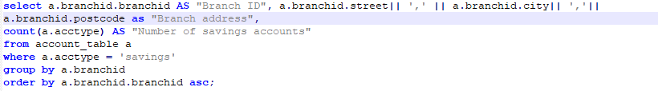

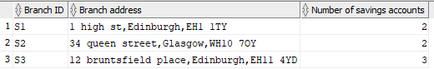

Question C - At each branch, find customers who have the highest balance in their savings account, displaying the branch ID, their names, and the balance.

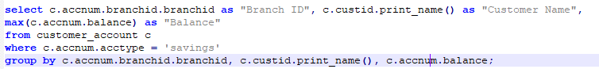

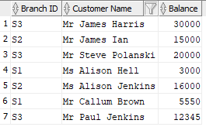

Question D - Find employees who are supervised by a manager and have accounts in the bank, displaying the branch address that the employee works in and the branch address that the account is opened with.

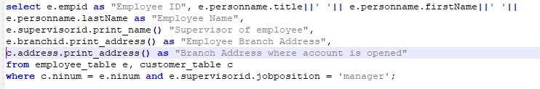



Question E - At each branch, find customers who have the highest free overdraft limit in all current accounts that are joint accounts, displaying the branch’s ID, the customer’s full names, the free overdraft limit in his/her current account.

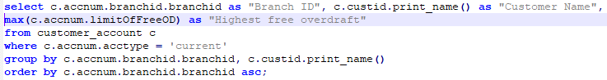

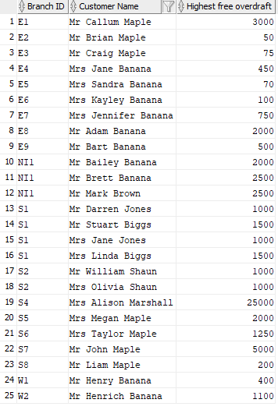

Question H – Employee Awards at the end of the year

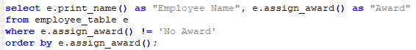

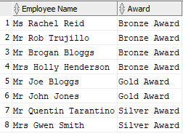

Task 5

## Critically discuss the advantages and disadvantages of the object-relational model against the relational model, based on the designs and implementations for the proposed bank database. (8 marks)

Entity Relational Databases are an easy to grasp way of creating databases. Each row has a primary key which is a unique identifier for that column. They are popular within businesses as they are easy to use an maintain. However, the functionality that object-relational databases offers makes relational databases a disadvantageous model to use in comparison.

The object relational model however is at a disadvantage for one part, as it requires time to learn all the concepts, especially if you are not familiar with object-oriented programming. There are many advantages however. An advantage of object relational databases are that they include features of object-oriented programming, such as inheritance. Inheritance was used in the re-design of the bank database, we can see that types Employee and Customer inherited attributes from the Person type, meaning that time was saved each time we created the tables as we did not need to declare certain values as they were already inherited when the subtype was created. Another advantage of types is that they can be created and used as composite attributes, meaning that if for example the customer table required a title, first name and last name we could create a type called name and declare those attributes in that name type, it can then be used as a composite attribute which saves time, memory and allows the use of dot notation.

Another advantage of object relational databases is member functions. These are advantageous because they allow complex operations to be performed meaning we can manipulate data on a wider scale. In the re-design, I created two member functions that printed values, this meant that they were printed as real values and not types, making the data look clearer.

Another advantage of object relational databases is collections. Object relational databases allow the use of varrays and nested tables, which allows to store, for instance, two types of phone and phone number for one customer.

# Task 6

Drop everything –

Drop type BMAccount_type force;

Drop type BMAddress_type force;

Drop type BMBranch_type force;

Drop type BMCustomer_type force;

Drop type BMEmployee_type force;

Drop type BMName_type force;

Drop type BMPerson_type force;

Drop type BMPhone_nested force;

Drop type BMPhone_nested_table force;

drop table account_table;

drop table branch_table;

drop table customer_account;

drop table customer_table;

drop table employee_table;